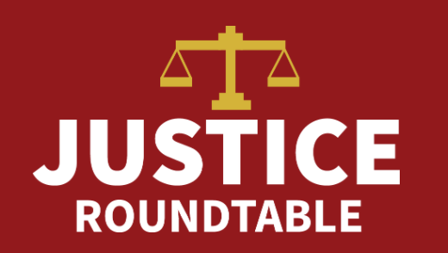
Call-to-Action: March 24th
Justice Roundtable

Social Media Toolkit Goals
As the House and Senate negotiate a stimulus package it is imperative that they include measures to help criminal justice impacted communities. In lieu of the ability to flood these offices with calls we must take to twitter to virtually storm the Capitol. Below includes the instructions on use of social media, proposed content of the messages, and the handles to direct your messages towards.

TWITTER Tips
Tips
- Message character limit (counting spaces) is 280.
- Attaching the photo should not count towards your 280 character limit.
- At the beginning of a Tweet, if you place a period before a Twitter handle, it will send that Tweet to that handle’s followers and to your followers. Without the period the tweet will not function as it should, if you have the member listed at the very front of the tweet.
- Adding a hashtag # will help to count metrics of our tweets. Include #cjfunding4COVID so we can correctly capture the number of tweets.
- Tweet at each target individually but use any of the messages below.
- If your representative's name makes the sample tweet below too long. Consider using abbreviations on key words or feel free to email: Stephanie Bazell at College & Community Fellowship for further suggestions and assistance: SBazell@collegeandcommunity.org

Twitter Targets
- Topline Targets include

Name | Position | Handle
Nancy Pelosi | Speaker of the House | .@SpeakerPelosi
Chuck Schumer | Senate Minority Leader | .@SenSchumer
Mitch McConell | Senate Maj. Leader | .@senatemajldr

- Additionally please tweet at your representatives and Members of Congress you know.
  - As a constituent, your voice will more likely be heard.
  - If you have close ties to any member of congress we also encourage you to reach out to them.
  - To find Twitter Handles for Members of Congress -- Google the name of the member, such as “Rep John Lewis” and the word “twitter” to find a twitter account in seconds!

Sample Posts
TWITTER
About the Tweets:
There are three different subheadings for tweeting that you will see below. Please choose at least one tweet from each of the subheadings and use that to tweet. If so inclined use them all!
Also please use the graphics we created as accompanying pictures. You can use that as a means to add even more members if you include them in the “tag picture” setting that comes up with graphic (see below). It will not impact the 280 word limit.
Tweet Recommendations - Safety Decarcerate
Tweet #1 and Top Tweet: .@______[Legislator Handle] Congress must reduce incarceration now to protect incarcerated ppl & beat #COVID19 nationwide. Incentivize state and local gov’ts to do the same. @JusticeRoundTab recs: https://bit.ly/2UozQck #cjfunding4COVID
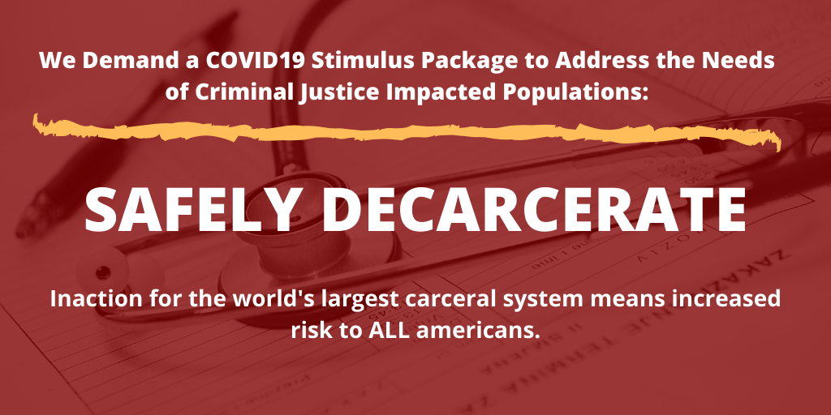

Protect Health and Safety of People Behind Bars
Tweet #2, Option A and B
A: .@______ [Legislator Handle] Prisons and jails do not have adequate medical care to respond to #COVID19. Congress must fund prevention, testing, and treatment at no-cost for ppl behind bars. @JusticeRoundTab recs: https://bit.ly/2UozQck #cjfunding4COVID

B: .@______ [Legislator Handle] Congress must support safe & successful #reentry of incarcerated ppl during the #COVID19 pandemic, including access to medical care & safe, supportive housing! @JusticeRoundTab recs: https://bit.ly/2UozQck #cjfunding4COVID
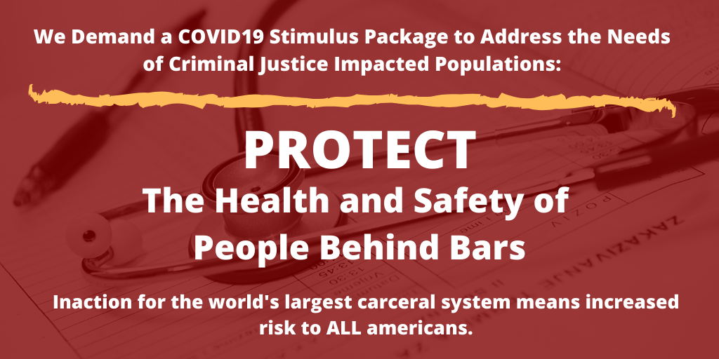

Help w/Successful Re-Entry
Tweet # 3:
.@______ [Legislator Handle] Congress must ensure that incarcerated ppl are not moved from one crisis to another - ppl released due to to #COVID19 need community-based services, incl. medical care, nutrition support, & safe, supportive housing! @JusticeRoundTab recs: https://bit.ly/2UozQck #cjfunding4COVID
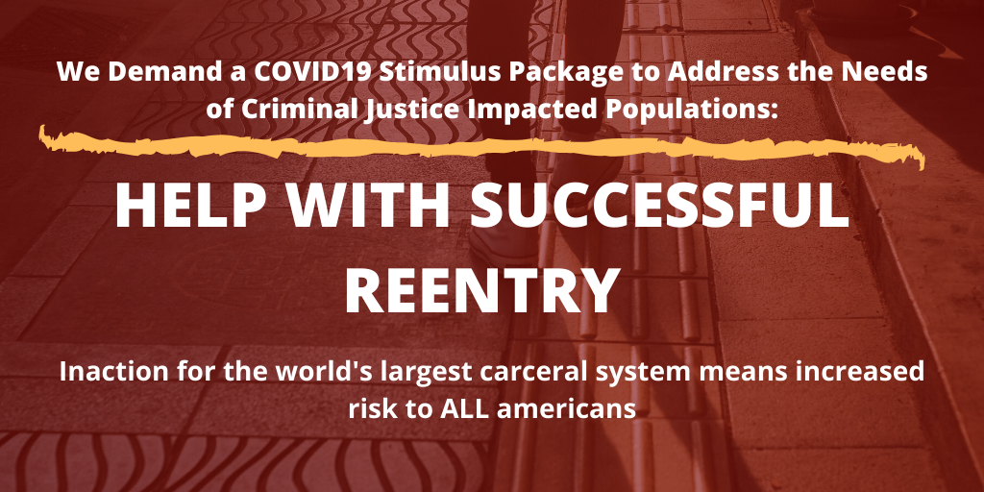

Final Post should look something like this:
