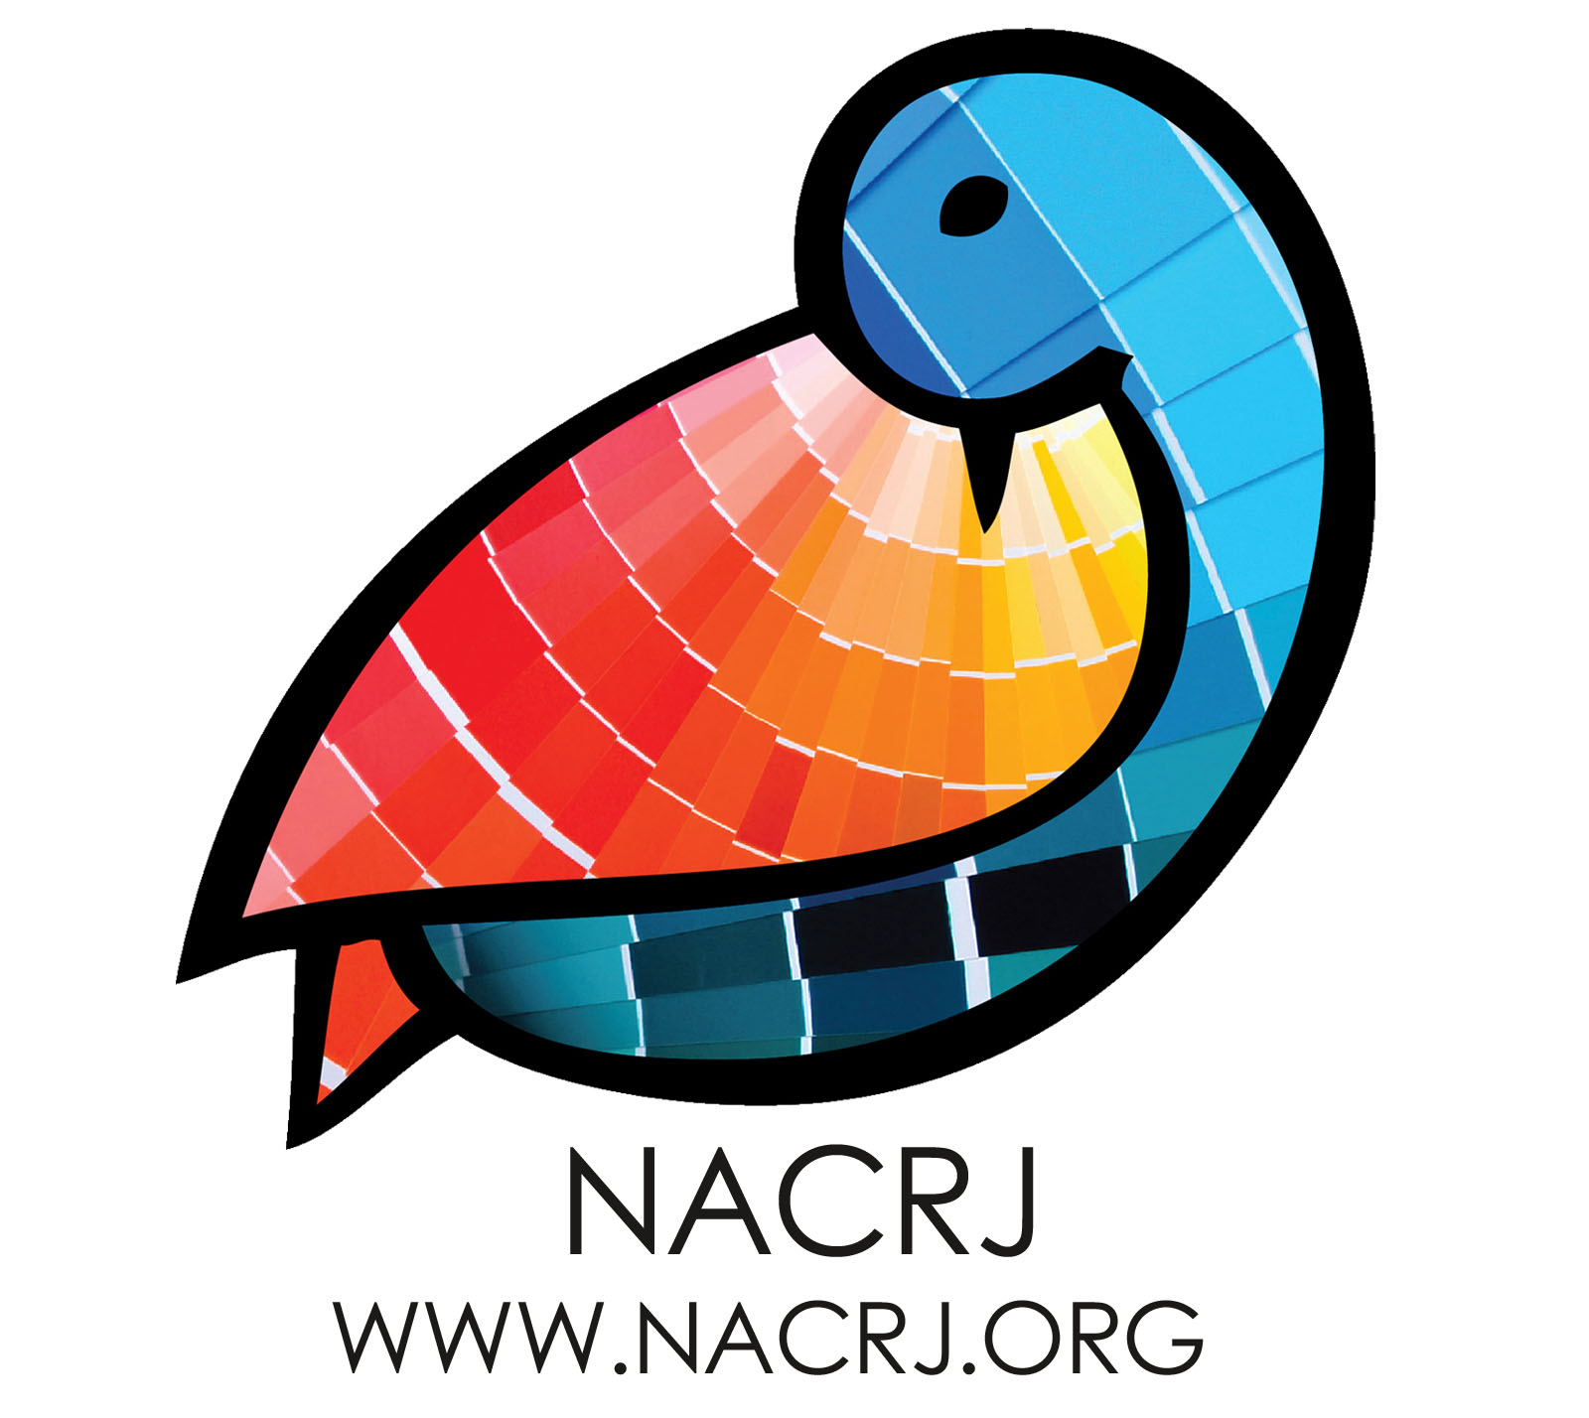
Application for Scholarship Support
for
Formerly Incarcerated People To Attend the
6th National Conference on Community and Restorative Justice
June 16 – 18th, 2017, Oakland Marriott

This scholarship is for conference support for a small number of people who might not otherwise be able to attend the NACRJ Conference this June. The goal of the support offering is to provide support for formerly incarcerated people to advance restorative justice work in communities. We are particularly interested in supporting non-traditional and non-professional community restorative justice practitioners.

Applications will be reviewed as they are received. All applications should be received prior to May 15, 2017. We will continue to review applications until all funds are expended. Please circle the appropriate response or provide the following information. Please email this completed form to louise@rjoyoakland.org

1) Are you formerly incarcerated?

Yes No

2) In which areas do you seek support? Circle all that apply.

a. Registration fees

b. Shared hotel room

c. Transportation/Airfare

3) Please provide the following information:

a. Name
b. Address
c. Email
d. Telephone

4) How will attending this conference help support your personal development, your restorative justice work and your community? (1 to 2 sentences)

